JAPANESE INDUSTRIAL STANDARD
JIS K 0122:1997
General rules for ion selective electrode method
May, 2021

ERRATUM

Position | Error | Correct
Between Page 3 and Page 6 | Pages 4 and 5 are missing. | Insert the two pages attached to this erratum.

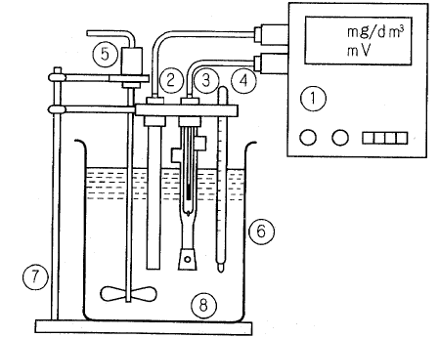
- Potentiometer or ion meter
② Ion selective electrode
③ Reference electrode (double liquid junction-type)
④ Thermometer
⑤ Stirrer
⑥ Sample container
⑦ Electrode stand
⑧ Sample
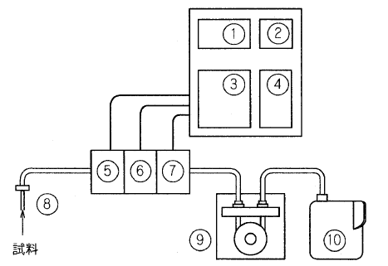
Fig. 1 Example of construction of batch type measuring apparatus using ion selective electrode
Sample
① Display part
② Printer
③ Signal amplifier (including analogue/digital signal converter)
④ Controller (including signal processor)
⑤ Ion selective electrode A
⑥ Ion selective electrode B
⑦ Reference electrode
⑧ Suction nozzle
⑨ Pump
⑩ Waste liquid tank
Fig. 2 Example of construction of flow type measuring apparatus using ion selective electrodes
PROTECTED BY COPYRIGHT

5.2 Measuring apparatus
(1) Type
(a) Potentiometer A d.c. potentiometer of high resistance (10¹² Ω min.) intended for measuring the response potential of an ion selective electrode. The response potential need to be converted to ion concentration by plotting or data processing.
This is, for example, a digital pH/mV meter or a pH/mV meter with a magnified scale.
(b) Ion meter A device for measuring the response potential of the ion selective electrode and converting it to concentration scale.
This is, for example, an analogue or digital ion meter (with a scale graduated in mg/dm³, mol/dm³, etc.).
(2) Use
(a) For laboratory or portable use An ion meter intended for measurement of each specific ion, such as sodium ion, fluoride ioin and cyanide ion.
(b) For ion monitor A monitor for each specific ion, such as a cyanide ion monitor, chloride ion monitor, fluoride ion monitor and sodium ion monitor, or a monitor of each type integrated into a water quality automatic monitoring device.
(c) For clinic examination A device incorporated into an automatic analyzer etc. for such purposes as examination of blood or other samples.
Some automatic analyzers are capable of measuring sodium ion, potassium ion, chloride ion, calcium ion, lithium ion, etc. in blood samples.
(d) For flow injection analysis apparatus A detector for the flow injection analysis (FIA), intended for determination of ion concentration.
(e) For exhaust gas monitor A device used for composition analysis of exhaust gas, for example, a hydrochloric gas monitor.
5.3 Types of ion selective electrodes Electrodes having an ion selectivity and incorporating a membrane that develops electric potential correponding to the ion concentration. These electrodes are classified into glass membrane electrodes, solid-state membrane electrodes, liquid membrane electrodes and gas-selective membrane electrodes according to the type of sensitive membrane it incorporates. Examples of main types of ion slective electrodes are shown in Table 1, and examples of their constructions, in Fig. 3.
5.4 Types of reference electrodes Electrodes of mainly single liquid junction and double liquid junction type, incorporating in its inner part a silver-silver chloride electrode, calomel [mercury-mercury chloride (1) electrode] or other electrode. They are mainly classified into the sleeve type and the ceramic type according to the type of the liquid junction part. Examples of constructions of reference electrodes are shown in Fig. 4.
PROTECTED BY COPYRIGHT

